**Online Registration**

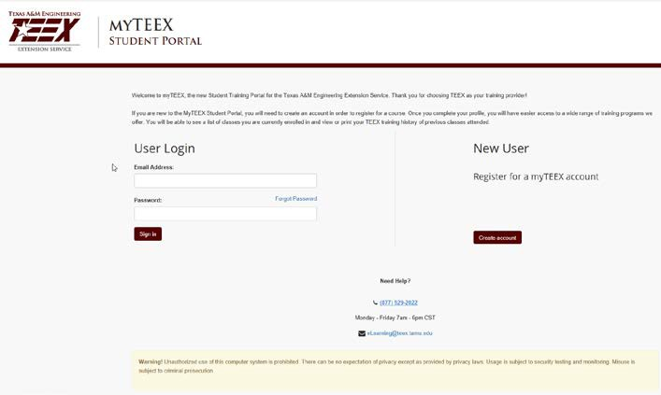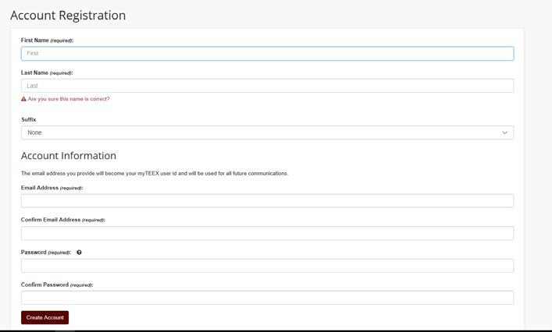

Step 2



**Select the “Create Account” button. You should be taken to the Account Registration page.**



Step 3



**Step 3: Complete the Account Registration page. Password requirements include the following:**

* **10 character minimum and must contain 3 of the following**
  + **Uppercase letters**
  + **Lowercase letters**
  + **Numbers**
  + **Non-alphabetic characters (Examples: !, ?, =, #)**

TEEX is making it easier for you to register yourself and/or others! You are now able to register yourself and other individuals via the MYTEEX Student Portal.

If you already have a MYTEEX Student Portal account, go to my.teex.org/teexportal and log in. You can then look up the course from the "Course Catalog" and register. You can also get there by clicking on the registration button on the course page of TEEX.org.

If you do not have a MYTEEX Student Portal account, follow the steps below to create one.



Step 1



**Type my.teex.org/teexportal into your browser’s address bar and press the “Enter” key on your keyboard. You should be taken to the page pictured below.**

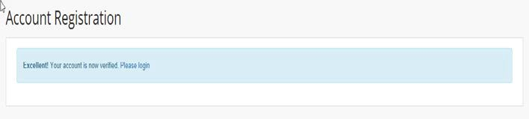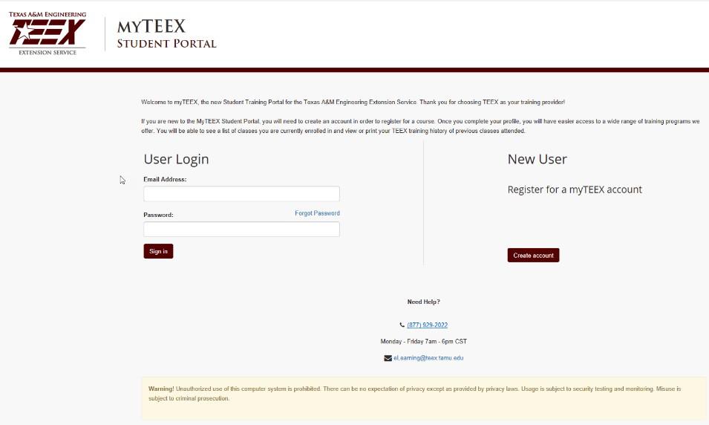

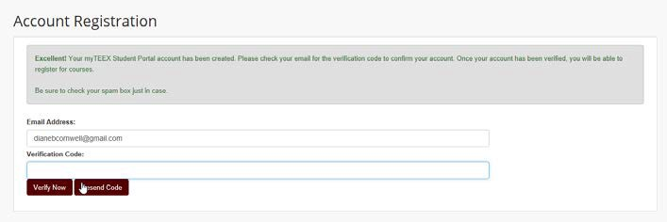

Step 4



**You will be taken to a page**

**requesting a verification code.**

**Do not close this page.**

**In a new browser tab, check the email you used to register. You should receive an email similar to the following example.**

Step 5

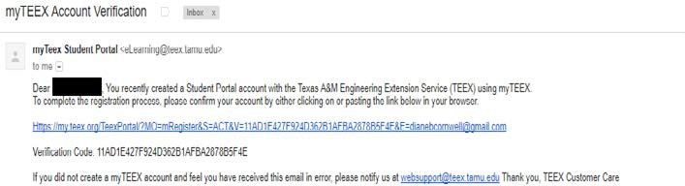

**Copy the verification code and**

**paste it into the Account Registration page shown in Step 4. Select “Verify Now”. You should be taken to the page below.**

Step 6



**Select “Please login”.**

**You will be taken back to the initial screen.**

Step 7



**Type in the email address you used to register and the password you created during the registration process.**

**Select “Sign In”.**

**You will be taken to the Welcome page.**

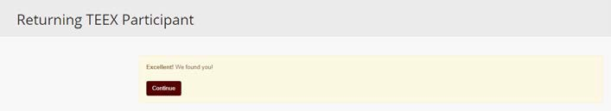



Step 9



**Type the requested information in at least one of the fields. (Your TEEX ID will give the best chance of finding your existing records.)**

**Select “Find Me!”**

**If the system finds you, you will see the message “Excellent! We found you.” If the system cannot find you, call 979-458-6833 or email** [**studentrecor**](mailto:studentrecords@teex.tamu.edu)[**ds@teex.tamu.edu.**](mailto:ds@teex.tamu.edu)

Step 10



Step 8



**If you have taken a class with TEEX previously, you will be in our system so select the “Yes, I have!”. If not, select “No, I’m New here.**

**If yes, you will be taken to the Returning TEEX Participant page.**



**Select Continue. Your portal account will be mapped with your TEEX account and you will be taken to your portal homepage.**

Step 11

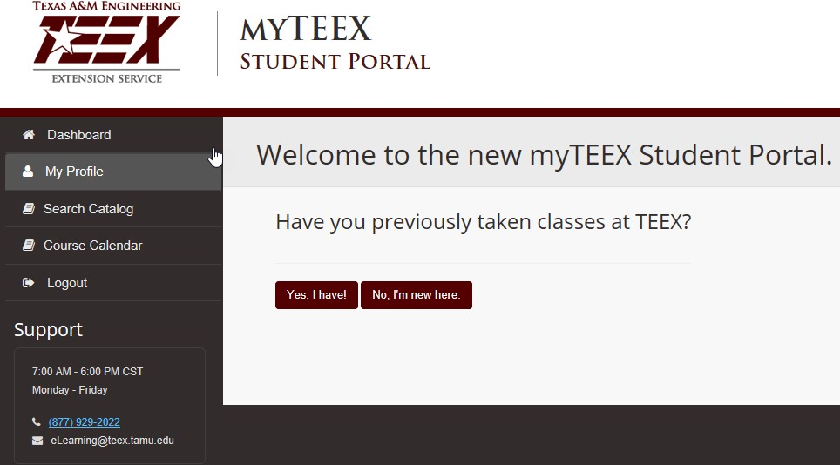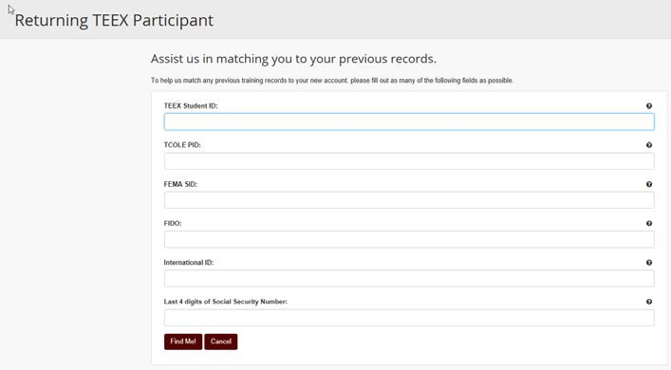

 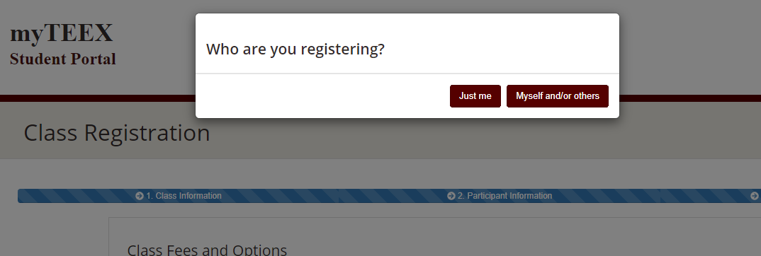

**In your student portal, you can now register for an upcoming course. Click "Search Catalog", then proceed to find the course you want to register for. If you clicked on “register” from TEEX.org, or from another link, you will be brought to the course page automatically.**

Step 12

**Decide who you are going to register. This is where you can select just yourself or yourself and/or others.**

**You can register others with their name and one other identifier, the best one being their TEEX ID**

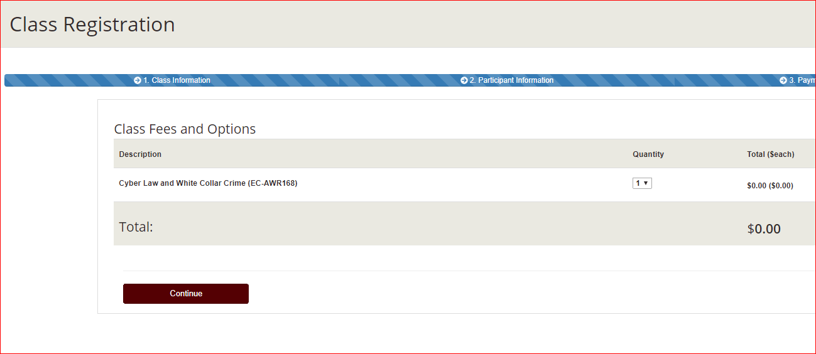

**If selecting just me, click continue, then update your information, finish by checking the “I agree”. A confirmation email will be sent.**

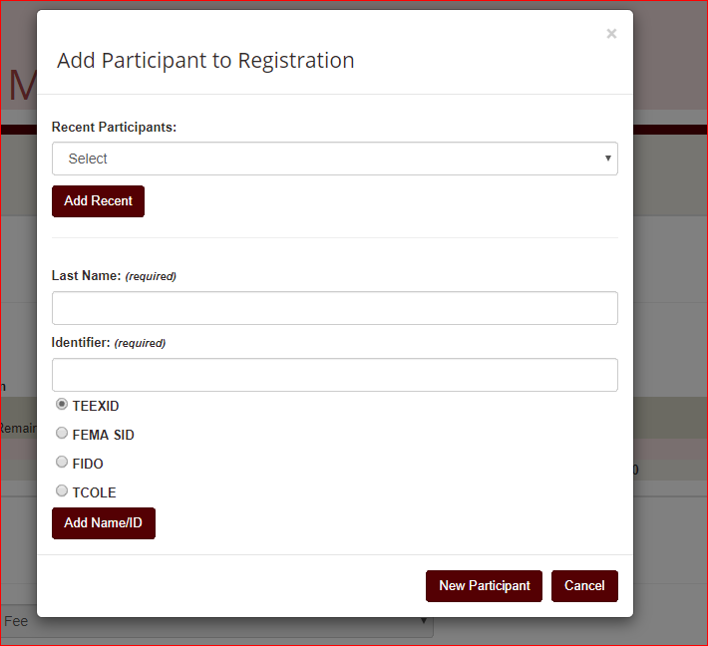

**If selecting myself and/or others, choose an option:**

1. **Use dropdown box to *select* participants that you have enrolled previously and then click *add recent.* Or…**
2. **enter *last name* and *TEEX ID* (or other identifier) to find existing TEEX student. Click *add name/ID.***

**Click on *new participant* to add a new student.**

Step 13

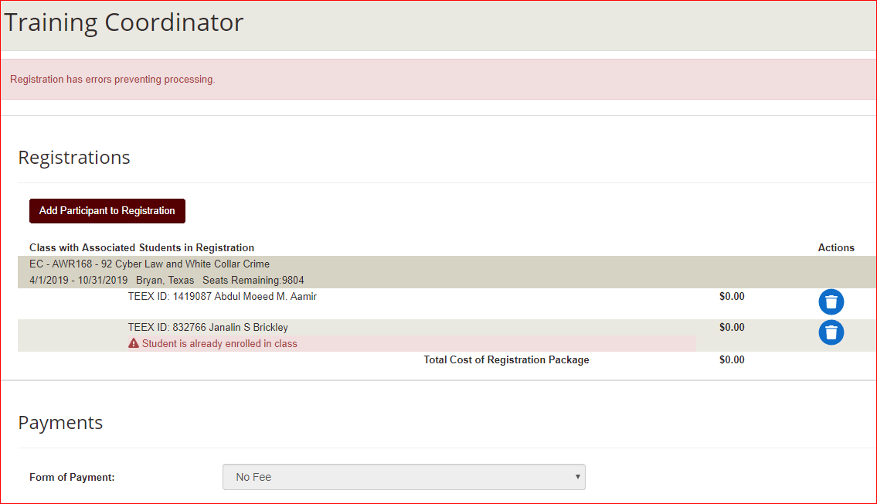

**The system will not allow you to register the same student in the same class. You will get a registration error message and the student will need to be removed by clicking on the trash can. This will only remove the student from the registration package, not the class.**

Step 14

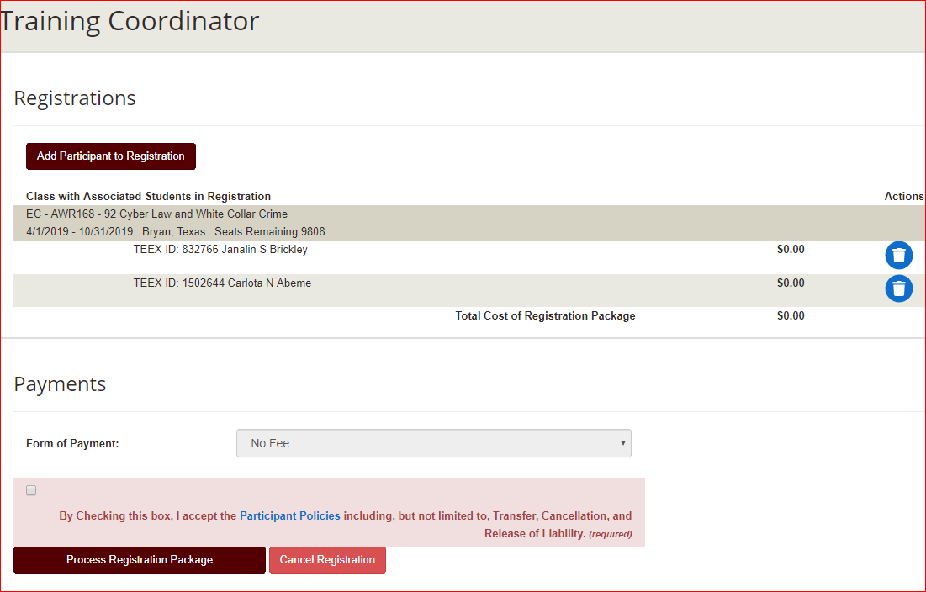

**A confirmation page will display and can be printed. A confirmation email will also be sent to the user processing this registration package and to each participant that has an email on file.**

Final Step/Confirmation

**Once all participants are listed in the package, click on *I agree* statementand then *process registration package***.

Step 15

