Charleston County Emergency Operations Center
8500 Palmetto Commerce Parkway
North Charleston, SC 29456
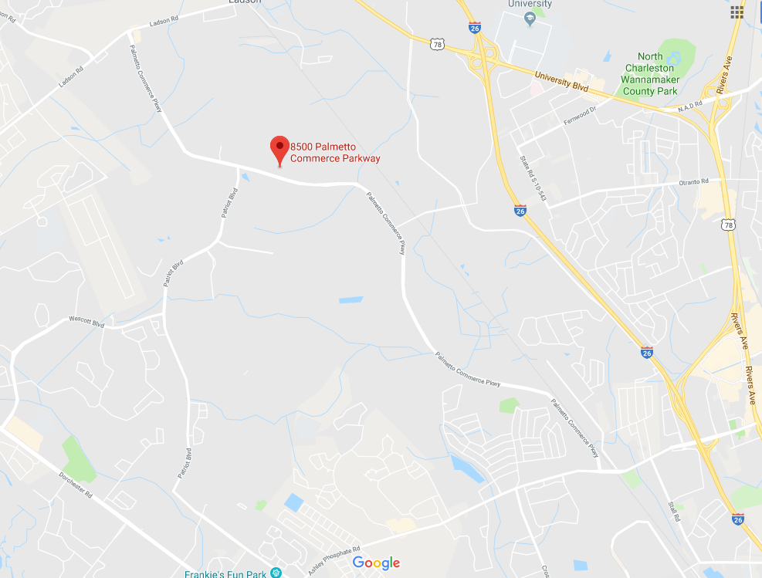

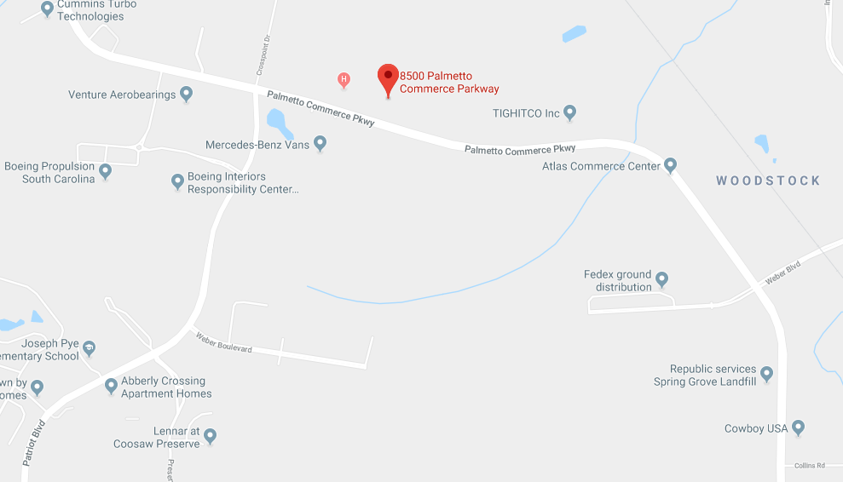

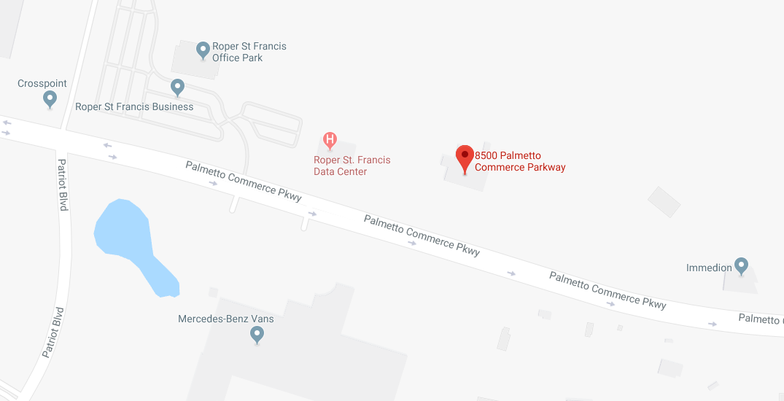

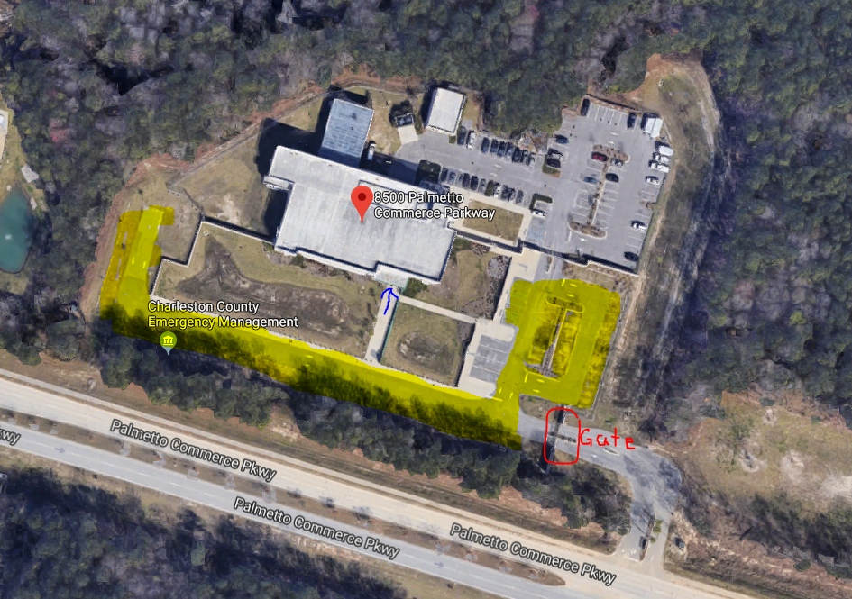
Highlighted area is for you to park. The front door is where the blue arrow points.

